**IoT and OT Hacking**

**What is IoT?**

IoT (Internet of Things) refers to the network of physical devices, vehicles, appliances, and other objects embedded with sensors, software, and connectivity, allowing them to collect, exchange, and analyze data.

**What is IoT Device Hacking?**

**IoT Hacking** involves unauthorized access or manipulation of IoT devices, exploiting vulnerabilities to steal data, disrupt operations, or cause harm.

Benefits of IoT hacking:

While hacking IoT devices is illegal and unethical, some individuals may exploit vulnerabilities for various reasons. Potential "benefits" (from a hacker's perspective) include:

1. **Data Theft**: Accessing sensitive information like personal data, financial details, or private communications.
2. **Surveillance**: Spying on users through connected cameras, microphones, or smart devices.
3. **Botnet Creation**: Using compromised devices to form a botnet for launching cyberattacks like DDoS.
4. **Ransom**: Locking devices or encrypting data and demanding a ransom for restoration.
5. **Privilege Escalation**: Gaining access to broader networks or systems through IoT vulnerabilities.

These actions are illegal and highly harmful, violating privacy and security. Ethical hacking practices focus on identifying and fixing vulnerabilities, not exploiting them.

**IoT (Internet of Things) Hacking Methodology:**

The methodology of IoT (Internet of Things) hacking typically involves several stages, each focused on identifying, exploiting, and maintaining control over IoT devices and systems. Here's a breakdown of each stage:

**1. Information Gathering**

The first step involves extracting critical information about the target IoT devices, such as:

* **IP Address**: Identifying the device's location on the network.
* **Protocols**: Determining which communication protocols are used (e.g., HTTP, MQTT).
* **Open Ports**: Scanning for exposed ports that might be vulnerable.
* **Device Type & Manufacturer**: Recognizing the type of device (e.g., smart thermostat, camera) and its manufacturer for known vulnerabilities.
* **Geo-Location**: Determining the physical location of the device.
* **Serial Number/Model**: Identifying specific models for known weaknesses or flaws.

**2. Vulnerability Scanning**

Once the device's details are gathered, vulnerability scanning helps identify weaknesses in the IoT system, including:

* **Weak Configurations**: Misconfigured device settings that can be exploited.
* **Firmware Bugs**: Identifying outdated or unpatched firmware vulnerabilities.
* **Weak Passwords**: Devices with default or easily guessable credentials.
* **Poor Encryption**: Devices that fail to securely encrypt communications, making them susceptible to interception or attacks.

**3. Launch Attacks**

After identifying vulnerabilities, attackers move on to exploiting these weaknesses to launch specific attacks, such as:

* **Denial of Service (DoS)**: Overloading the device or network to make it unavailable.
* **Rolling Code Attacks**: Intercepting and predicting rolling codes used in IoT security systems (e.g., smart locks).
* **Jamming Signal Attacks**: Disrupting wireless communication between devices, such as using radio frequency jamming.
* **Sybil Attacks**: Impersonating multiple devices on a network to gain control or cause chaos.
* **Man-in-the-Middle (MITM) Attacks**: Intercepting and manipulating communication between two devices.
* **Data & Identity Theft**: Stealing sensitive information like personal data, login credentials, or location data.

**4. Gain Remote Access**

In this phase, attackers use discovered vulnerabilities to gain remote access to the IoT device.

* This may involve turning the device into a **backdoor**, allowing the attacker to infiltrate the network without being detected by traditional security measures like firewalls, antivirus software, or Intrusion Detection Systems (IDS).
* This access may be used to launch further attacks or gain access to internal systems.

**5. Maintain Access**

To ensure continued control over the compromised IoT device, attackers use several techniques:

* **Log Cleansing**: Deleting or altering logs to avoid detection.
* **Firmware Updates**: Installing custom firmware that supports backdoors or other malicious payloads.
* **Malicious Programs**: Using malware, such as Trojans or remote access tools (RATs), to ensure ongoing access to the device.
* **Persistence**: Ensuring that even if the device is reset or rebooted, the attacker can still regain control.

**What is OT?**

Operational technology is the software and hardware designed to detect or cause changes in industrial operations through direct monitoring and/or controlling of industrial physical devices.

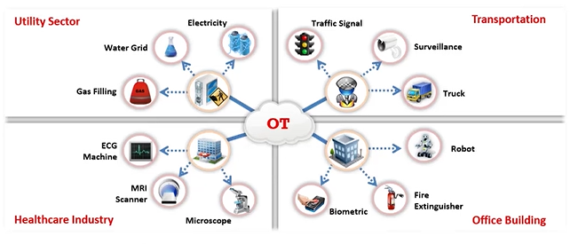

**Gather Information Using Online Footprinting Tools:**

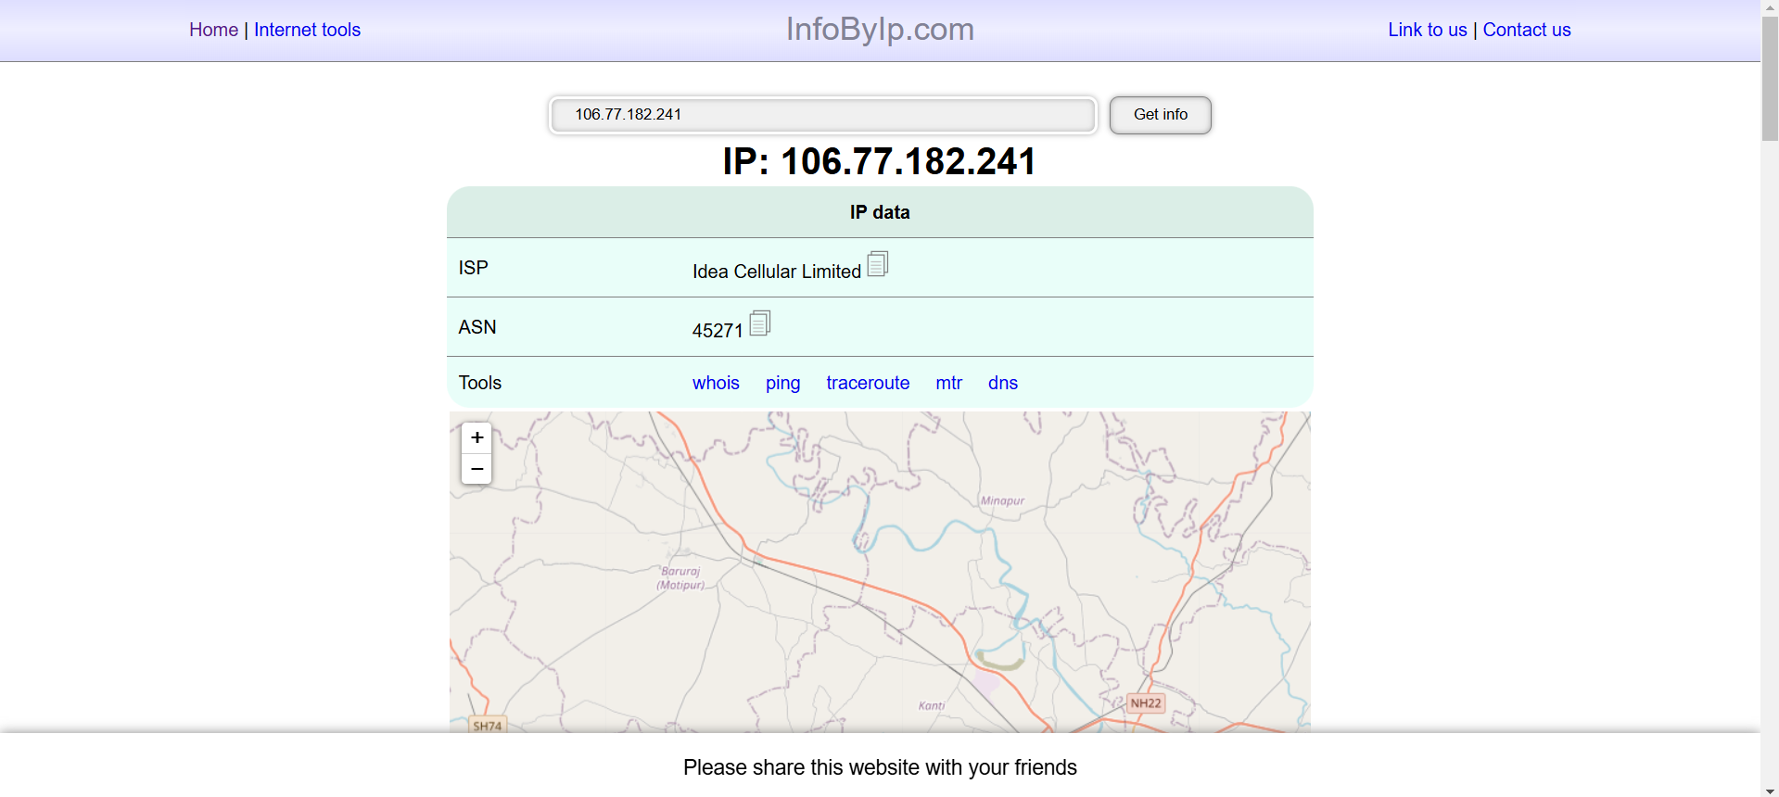

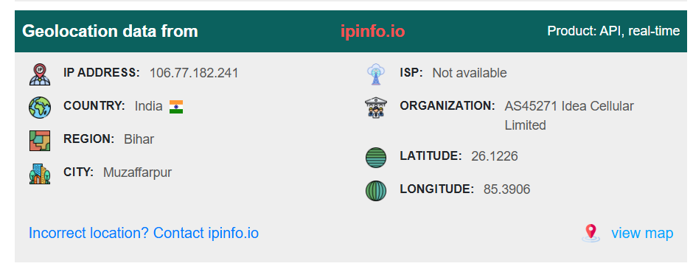

**Capture and Analyze IoT Traffic using Wireshark:**

